DIGITAL MARKETING

Assignment 4 - Create an email newsletter and posting it in blog

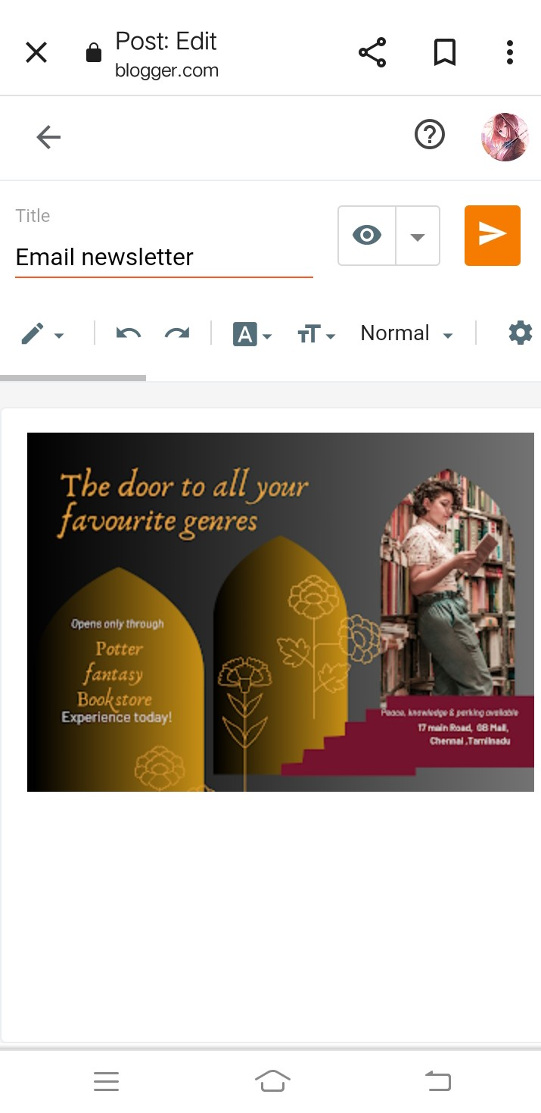

Figure: post on blog

Email newsletter:

<https://www.blogger.com/blog/post/edit/599604069426207278/3620183279856340233>

Email newsletter:

